ANALYSTLAB AFRICA
Machine Learning Internship Programme — Week 3
Model Evaluation & Feature Importance Report
Customer Churn Prediction — Technical Evaluation

1. Evaluation Setup
Five models were trained on a SMOTE-balanced training set (8,278 rows, 50/50 class split) and evaluated on an untouched, stratified test set (1,409 rows, retaining the real 73.5%/26.5% class distribution). Five metrics were computed for each model: Accuracy, Precision, Recall, F1-score, and ROC-AUC.

2. Full Results Table
Model | Accuracy | Precision | Recall | F1 | ROC-AUC | Train Time (s)
Random Forest | 0.761 | 0.536 | 0.743 | 0.623 | 0.836 | 2.17
Logistic Regression | 0.764 | 0.543 | 0.711 | 0.616 | 0.832 | 0.04
Gradient Boosting | 0.770 | 0.551 | 0.717 | 0.623 | 0.830 | 2.83
XGBoost | 0.764 | 0.547 | 0.634 | 0.587 | 0.814 | 0.37
Decision Tree | 0.738 | 0.505 | 0.727 | 0.596 | 0.783 | 0.03

3. Confusion Matrices
Confusion matrices reveal the trade-off each model makes between catching churners (top-right vs bottom-right cells) and avoiding false alarms (bottom-left cell).
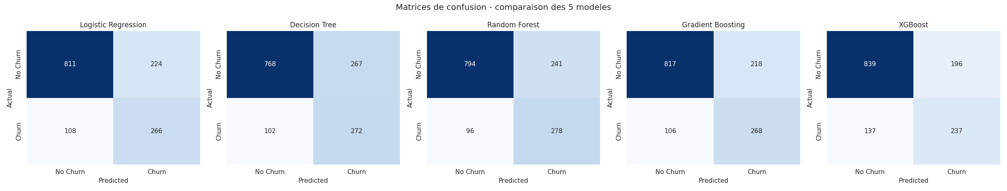
Figure 1. Confusion matrices for all five models on the test set.

4. ROC & Precision-Recall Curves
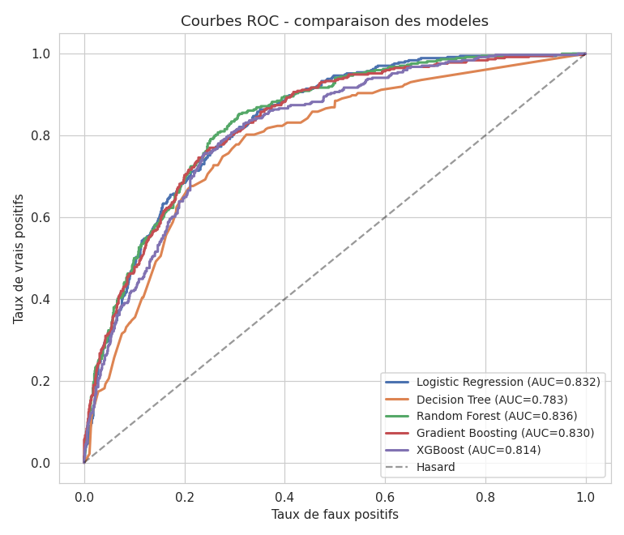
Figure 2. ROC curves — Random Forest leads with AUC = 0.836.
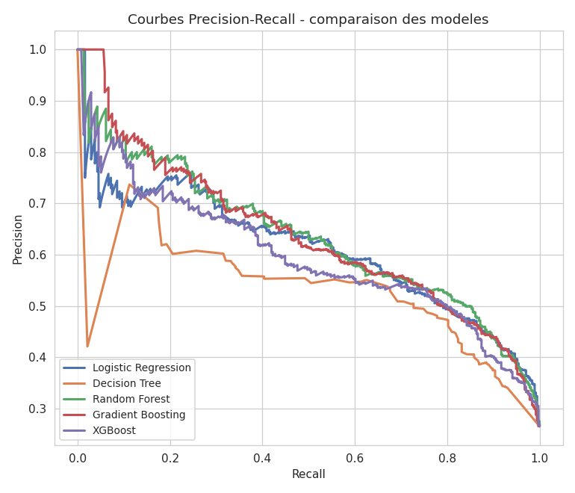
Figure 3. Precision-Recall curves — more informative than ROC under class imbalance.

5. Model Comparison Chart
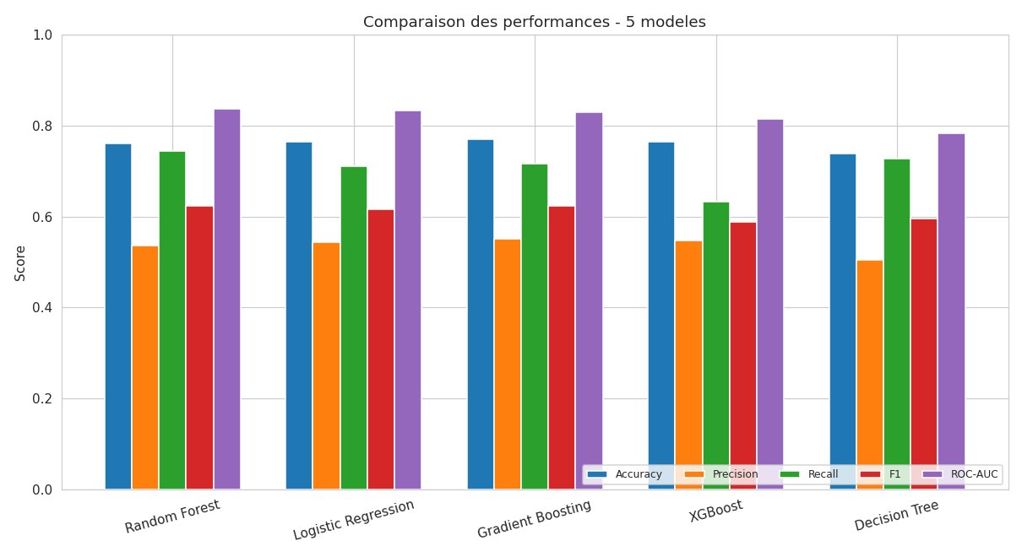
Figure 4. Side-by-side comparison of all five metrics across models.

6. Feature Importance
Random Forest importances (Gini-based) were used to rank predictors:
Rank | Feature | Importance
1 | Contract | 0.176
2 | tenure | 0.133
3 | MonthlyCharges | 0.093
4 | AvgChargePerService | 0.090
5 | TotalCharges | 0.078
6 | InternetService_Fiber optic | 0.069
7 | TenureGroup | 0.065
8 | NumServicesSubscribed | 0.041
9 | PaymentMethod_Electronic check | 0.032
10 | InternetService_No | 0.030
11 | OnlineSecurity_Yes | 0.029
12 | Dependents | 0.025
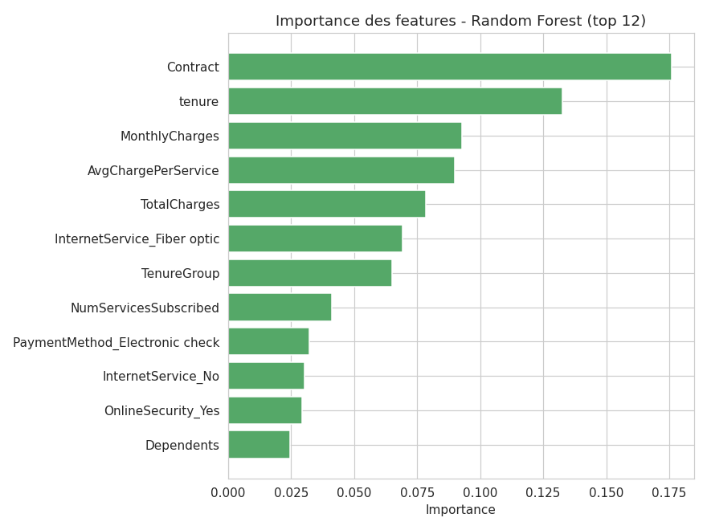
Figure 5. Top 12 features by Random Forest importance.
Discussion: the two engineered features from Week 2 (AvgChargePerService, TenureGroup) both rank in the top 7, alongside their raw counterparts — cross-validating that the feature engineering added genuine predictive signal rather than redundant noise. Contract and tenure together account for roughly 31% of total importance, confirming that commitment length and customer lifecycle stage are the dominant churn drivers, ahead of any single service or demographic attribute.

7. Learning Curve
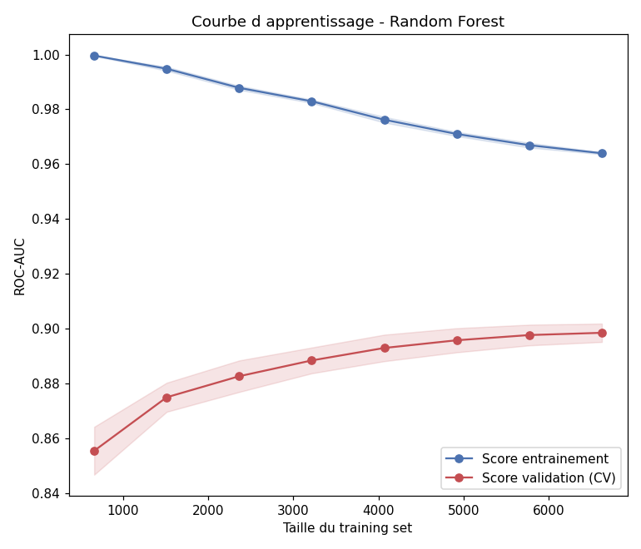
Figure 6. Learning curve for Random Forest — training and validation ROC-AUC converge as training size grows.
The validation score rises steadily and plateaus near 0.90 (cross-validated on the balanced training set), while the gap to the training score narrows but does not fully close — indicating mild variance that more training data or regularization (e.g. limiting tree depth further) could reduce, but not severe overfitting.

8. Prediction Distribution
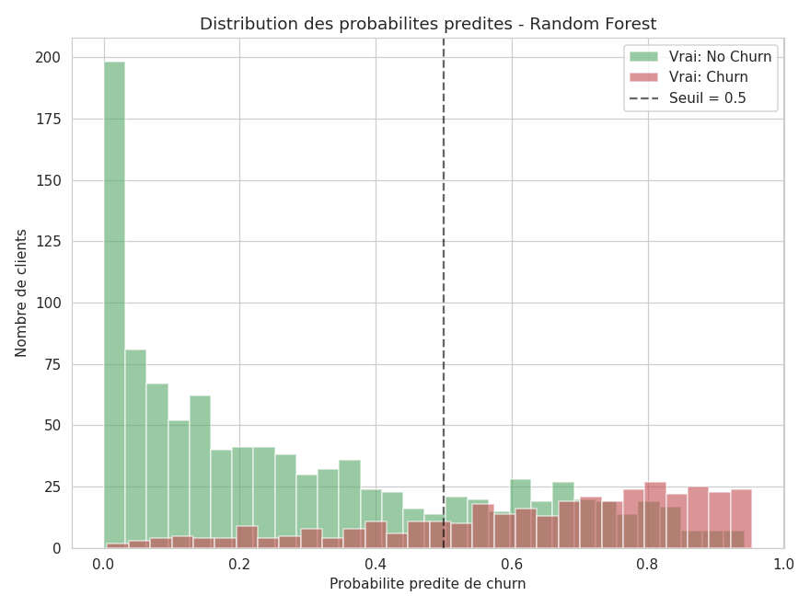
Figure 7. Distribution of predicted churn probabilities by actual class (Random Forest).
The two distributions are reasonably well separated, with actual non-churners concentrated at low predicted probabilities and actual churners shifted higher — but with meaningful overlap around the 0.5 threshold. This overlap is the direct source of the model's false positives and false negatives, and is a natural target for threshold tuning in a follow-up iteration.

9. Conclusion
Random Forest is confirmed as the strongest overall model on this test set (ROC-AUC 0.836, Recall 0.743), with Logistic Regression and Gradient Boosting as close, viable alternatives depending on whether interpretability or precision is prioritized by the business. Decision Tree and XGBoost underperformed relative to the other three on the metrics most relevant to this business problem.

